Intransitive - Has No Objects or Complements
Subject | Intransitive Verb
Cameras | Flashed
“Be” Verb (Copular) – Has One Complement
Subject | Be Verb | Subject Complement
I | Am | An optimist (NP)
The writers | Are | Very cold (AdjP)
He | Is | In Trouble (PP)
Linking Verb – Has Complement
Subject | Linking Verb | Subject Complement
The trail | Looked | Steep (ADJP)
My sister | Became | A nurse (NP)
The student | Felt | Underprepared (PP)
Transitive (#5 on p. 24) – Has one Object
Subject | Transitive Verb | Direct Object
Weasels | Stalk | Rabbits
Ditransitive – Has Two Objects or Complements
Subject | Transitive Verb | Object/Complement | Object/Complement
Marie | Sent | Ramon | A birthday gift
The director | Considered | The performance | A success
The critic | Called | The acting | brilliant

Phillip’s Step-by-step for Identifying Sentence Patterns
- Identify the headword of Subject (NP) and Predicate (VP)
- Identify all the parts of the Subject (Determiners, Adjective Phrases)
- Identify any Adverbials (modifying the verb or modifying the sentence)
  - In Unit Two all Adverbials will be ADVPs or PPs – Ignore all Adverbials when Identifying Sentence Patterns!
- Assume the Sentence is “Intransitive” to Start and look for evidence that it is not
- Look for “Be” verbs first.
- If you see any “be” verb it must be “copular be” (is, are, was, were) – will see exceptions to this in Unit 3 and 4
- Is it a Linking Verb?
  - Linking Verbs can usually be replaced by a “be” verb with only subtle change in meaning.
    - Linking Verb: He seems upset. ----- Be Verb: He is upset.
- Is there something after the main verb? If so, what is it and what is it doing? (Remember to ignore Adverbials!)
  - A noun phrase – could be an Object or Complement
  - An adjective phrase – could Modifying a Noun or could be a Complement
  - Prepositional Phrase – could be Modifying a Noun, serving as a Complement, or could be an Adverbial (If so, ignore it)
  - Adverb – In Unit Two, must be an ADVP and Adverbial, but may be INSIDE larger phrases (VPs and ADJPs for instance)
- Are there two things after the main verb? You may have a “Ditransitive” Sentence
  - If you do have two things,.
    - Check if either is an Adverbial – Adverbials cannot be Objects or Complements (except in rare, none in Unit Two)
    - Ditransitive sentences will have at least one NP after the verb phrase (the direct object)
    - Indirect Objects can only be NPs
    - Object Complements can be only NPs, ADJPs and PPs (in rare cases, they might be ADVPs not on Exam Two)
Copular Be Examples

Copular “Be” Sentence with a Prepositional Phrase as a Subject Complement (#1 on p. 24)
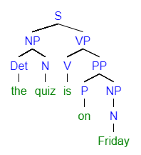
Copular “Be” Sentence with an Adjective Phrase as Subject Complement (#2 on p. 24)
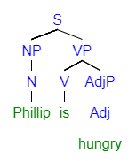

Copular “Be” Sentence with a Noun Phrase as a Subject Complement (#2 on p. 24)
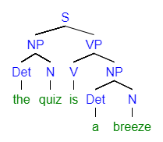
Linking Verb Examples

Linking Verb with an Adjective Phrase as a Subject Complement (#3 on p. 24)
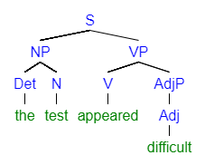
Linking Verb with a Noun Phrase as a Subject Complement (#3 on p. 24)
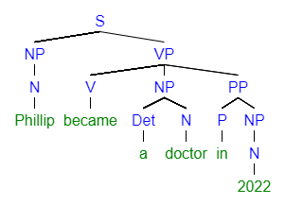
Linking Verb with a Prepositional Phrase as a Subject Complement (#3 on p. 24)

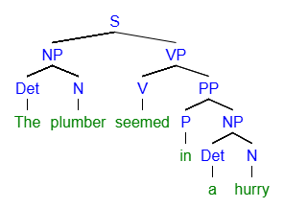

Intransitive Verb Examples
Intransitive Verb (#4 on p. 24)
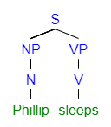

Intransitive Verb with Optional Adverbials

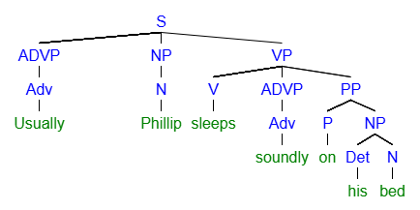

Transitive Verb Examples
Transitive Verb with a Direct Object (#5 on p. 25)
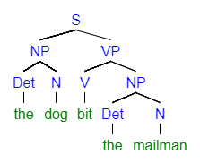

Transitive Verb with a Direct Object and an Optional Adverbial (Prepositional Phrase)
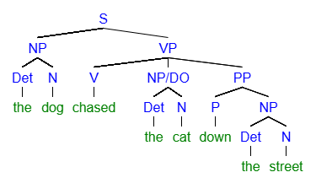
Ditransitive with Direct Objects and Indirect Objects Examples

Ditransitive verb with a Direct Object (a bone) and an Indirect Object (the dog) (#6 on p. 24)
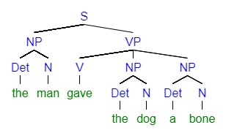
Ditransitive verb with a Direct Object (100 dollars), an Indirect Object (them), and an optional Adverbial (up front) (#6 on p. 24)
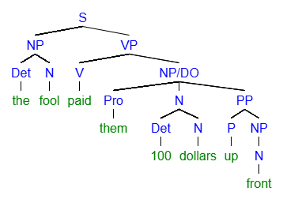
Ditransitive Sentences with Direct Objects and Object Complements Examples
Ditransitive verb with a Direct Object (the test) and an Adjective Phrase as an Object Complement (difficult) (#7 on p. 24)
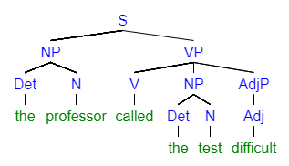
Ditransitive verb with a Direct Object (the test) and a Noun Phrase as an Object Complement (a beast) (#7 on p. 24)
